

The Margaret Mead School

Dear Parents,

These are most of the supplies that your child will need for the upcoming 2025-2026 school year. In September, there might be a few add-ons from each teacher. If your child runs out of any of these supplies during the school year, you will need to replace them. Please purchase additional pencils, crayons, glue sticks, and scissors to be kept at home since supply boxes will remain in school. You can use this list to purchase supplies over the summer.
- 5 Wide Ruled marble notebooks (no spiral)-Please write your child’s full name on each book
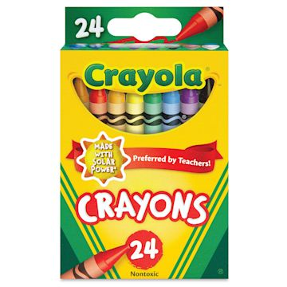
- 1 set of headphones (no wireless or rechargeable headphones, and no earbuds) in a Ziploc gallon size bag. Please write your child’s name on the headphones and the Ziploc bag.
- 2 boxes of Crayola crayons (16 or 24) **No colored pencils

- 6 glue sticks (solid, not liquid) We strongly recommend ELMER’s or AVERY (Staples)
- Fiskars child safety scissors (sold at Staples)
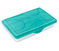
- 5 pocket folders with the pockets on the bottom, not side. Please write your child’s full name on each folder.
- A full size school bag-large enough to hold folders, snacks, and lunchboxes
- 1 supply box large enough to hold pencils, crayons, glue sticks, and scissors
- 1 lunch box
- 10 sharpened #2 pencils (each week)
- 1 box of quart Ziploc bags
- 2 rolls of paper towels
- 2 boxes of tissues
- 1 package of Lysol wipes
- 1 package of baby wipes
- 1 bottle of hand sanitizer
- 1 3 pack of Expo Dry Erase Markers
Thank you for your cooperation,
Sincerely,
The Kindergarten Teachers

